Maine Criminal Justice Academy

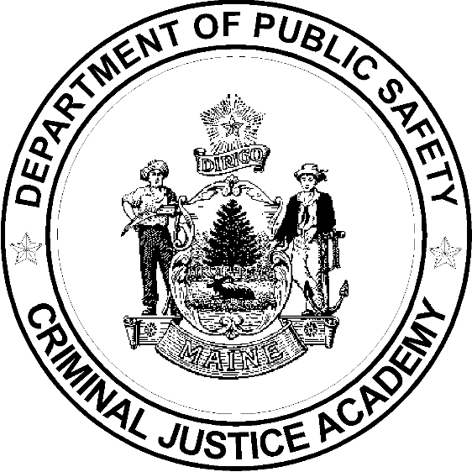

Basic Corrections Training Program Curriculum

Updated July 18, 2018

Curriculum Outline

  - Foundations
1.1.0 Administrative Details, Orientation, Testing,
Graduation 10.5 Hours
1.2.0 Foundations of an Effective Correctional Officer 3.5 Hours
1.3.0 Sociology of a Correctional Facility 4 Hours
1.4.0 Physical Fitness & Nutrition 18 Hours
Section Hours 36

2.0.0 Ethics and Professionalism
2.1.0 Professionalism, Ethics, and Administrative
Investigations 4 Hours
Section Hours 4

  - The Law and the Criminal Justice System
3.1.0 Law Enforcement, Courts, and Corrections 2 Hours
3.2.0 Constitutional & Civil Rights, and ADA 4 Hours
3.3.0 Correctional Standards 1.5 Hours
3.4.0 Prison Rape Elimination Act (PREA) 4 Hours
3.5.0 Investigations in Corrections 2 Hours
Section Hours 16

4.0.0 Professional Communications
4.1.0 Report Writing 6 Hours
4.2.0 Log Books and Record Keeping 1.5 Hours
4.3.0 Basic Communications, Body Language, and IPC Skills 16 Hours
4.4.0 Cultural Diversity and Awareness 3 Hours
Section Hours 26.5

5.0.0 Resident/Inmate Management
5.1.0 Inmate Admitting and Release and Classification 2 Hours
5.2.0 Security and Count Procedures 2 Hours
5.3.0 Inmate Supervision 4 Hours
5.4.0 Women Offenders and Cross-Gender Supervision 2 Hours
5.5.0 Inmate Discipline and Inmate Grievances 2 Hours
5.6.0 Inmate Hygiene and Facility Sanitation 1 Hour
5.7.0 Inmate Programs and Services 1 Hour
Section Hours 14

6.0.0 Special Management Residents/Inmates
6.1.0 Sex Offenders 1.5 Hours
6.2.0 Homosexual, Bisexual, and Transgender Prisoners 2 Hours
6.3.0 Security Threat Groups 4 Hours
6.4.0 Mentally Ill Inmates and Crisis Intervention 6 Hours
6.5.0 Developmental Disabilities / Disabled Inmates 3 Hours
6.6.0 Elder Inmates 1 Hour
6.7.0 Suicidal Inmates 4 Hours
6.8.0 Domestic & Sexual Assault, and Stalking 8 Hours
Section Hours 29.5

7.0.0 Safety and Security
7.1.0 Basic Officer Safety and Security 3 Hours
7.2.0 Situational Use of Force 8 Hours
7.3.0 Mechanics of Restraint and Control 24 Hours
7.4.0 Contraband 2 Hours
7.5.0 Area, Cell and Body Searches 8 Hours
7.6.0 Key and Tool Control 1 Hour
7.7.0 Security in a Non-Secure Setting 3 Hours
7.8.0 Cell Extractions 8 Hours
Section Hours 57

8.0.0 MEDICAL & MENTAL HEALTH
8.1.0 Communicable Diseases 1.5 Hours
8.2.0 Drugs and Drug Recognition 2 Hours
8.3.0 Substance Abuse Awareness 2 Hours
8.4.0 Correctional Officer Stress, Substance Abuse, and
Suicide 2 Hours
8.x.x Mental Health First Aid 8 Hours
Section Hours 15.5

9.0.0 Critical Incident Prevention and Management
9.2.0 Assaults, Riots, and Other Disturbances 2 Hours
9.3.0 Hostage Situations 1.5 Hours
9.4.0 Fire and Fire Safety 2.5 Hours
9.5.0 Escapes 1.5 Hours
9.6.0 Unattended Death 1 Hour
9.7.0 Critical Incident Stress and Debriefing for Staff 1 Hour
Section Hours 9.5

Total BCTP Instructional Time 208 Hours

